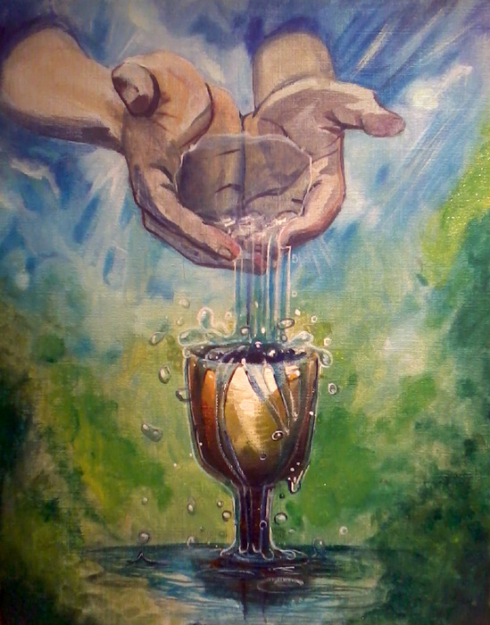

"Let It Pour...
Emptying Myself...
Being Filled With the Father"

Psalm 139 Woman – Gathering of the Vessels
March 28, 2014
7:00 pm
with
Audrea Winbush Lott – Life Coach

John 3:30
The Message (MSG)
29-30 “That’s why my cup is running over. This is the assigned moment for him to move into the center, while I slip off to the sidelines.

John 3:29-30
New Living Translation (NLT)
29 It is the bridegroom who marries the bride, and the best man is simply glad to stand with him and hear his vows. Therefore, I am filled with joy at his success. 30 He must become greater and greater, and I must become less and less.

Mark 14:35
The Message (MSG)
35-36 Going a little ahead, he fell to the ground and prayed for a way out: “Papa, Father, you can—can’t you?—get me out of this. Take this cup away from me. But please, not what I want—what do you want?”

Mark 14:35-36
New Living Translation (NLT)
35 He went on a little farther and fell to the ground. He prayed that, if it were possible, the awful hour awaiting him might pass him by. 36 “Abba, Father,”[a] he cried out, “everything is possible for you. Please take this cup of suffering away from me. Yet I want your will to be done, not mine.”

Philippians 2:13
King James Version (KJV)
13 For it is God which worketh in you both to will and to do of his good pleasure.

Philippians 2:13
Amplified Bible (AMP)
13 [Not in your own strength] for it is God Who is all the while [a]effectually at work in you [energizing and creating in you the power and desire], both to will and to work for His good pleasure and satisfaction and [b]delight.

Philippians 2:13
The Message (MSG)
Rejoicing Together
12-13 What I’m getting at, friends, is that you should simply keep on doing what you’ve done from the beginning. When I was living among you, you lived in responsive obedience. Now that I’m separated from you, keep it up. Better yet, redouble your efforts. Be energetic in your life of salvation, reverent and sensitive before God. That energy is God’s energy, an energy deep within you, God himself willing and working at what will give him the most pleasure.

Philippians 1:6
Amplified Bible (AMP)
6 And I am convinced and sure of this very thing, that He Who began a good work in you will continue until the day of Jesus Christ [right up to the time of His return], developing [that good work] and perfecting and bringing it to full completion in you.

